1. Some of the bootstrap classes that we can use with images  
   2. Along the way, we will also build a simple bootstrap photo gallery
2. we have already discussed 4 bootsrap classes that are extremely useful to style images.   
   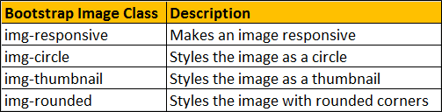  
     
   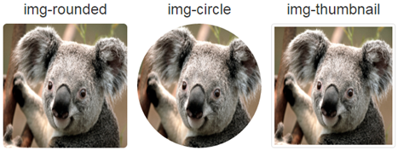  
     
   **Bootstrap classes to position an image**   
   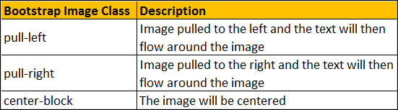  
     
   **A simple bootstrap image gallery**   
   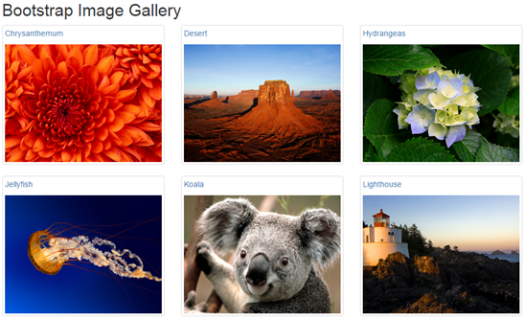  
     
   The image gallery should  
   1. Display 4 thumbnails on a large screen size  
   2. Display 3 thumbnails on a medium screen size  
   3. Display 2 thumbnails on a small screen size  
   4. Display 1 thumbnail on an extra small screen size  
   5. When you click on a thumbnail, the original image should be displayed  
     
   Here is the complete HTML of the image gallery

<div class="container">

    <div class="row">

        <div class="col-lg-12">

            <h2>Bootstrap Image Gallery</h2>

        </div>

        <div class="col-lg-3 col-md-4 col-sm-6">

            <a href="Images/Chrysanthemum.jpg" class="thumbnail">

                <p>Chrysanthemum</p>

                <img src="Images/Chrysanthemum.jpg" />

            </a>

        </div>

        <div class="col-lg-3 col-md-4 col-sm-6">

            <a href="Images/Desert.jpg" class="thumbnail">

                <p>Desert</p>

                <img src="Images/Desert.jpg" />

            </a>

        </div>

        <div class="col-lg-3 col-md-4 col-sm-6">

            <a href="Images/Hydrangeas.jpg" class="thumbnail">

                <p>Hydrangeas</p>

                <img src="Images/Hydrangeas.jpg" />

            </a>

        </div>

        <div class="col-lg-3 col-md-4 col-sm-6">

            <a href="Images/Jellyfish.jpg" class="thumbnail">

                <p>Jellyfish</p>

                <img src="Images/Jellyfish.jpg" />

            </a>

        </div>

        <div class="col-lg-3 col-md-4 col-sm-6">

            <a href="Images/Koala.jpg" class="thumbnail">

                <p>Koala</p>

                <img src="Images/Koala.jpg" />

            </a>

        </div>

        <div class="col-lg-3 col-md-4 col-sm-6">

            <a href="Images/Lighthouse.jpg" class="thumbnail">

                <p>Lighthouse</p>

                <img src="Images/Lighthouse.jpg" />

            </a>

        </div>

        <div class="col-lg-3 col-md-4 col-sm-6">

            <a href="Images/Penguins.jpg" class="thumbnail">

                <p>Penguins</p>

                <img src="Images/Penguins.jpg" />

            </a>

        </div>

        <div class="col-lg-3 col-md-4 col-sm-6">

            <a href="Images/Tulips.jpg" class="thumbnail">

                <p>Tulips</p>

                <img src="Images/Tulips.jpg" />

            </a>

        </div>

    </div>

</div>